CSE 421
Lab 2: Introduction to Packet Analysis and Network Simulation
ID: 22299116

Home Task 1:
Visit any http website while monitoring the network traffic. Now filter only the http packets. Observe the headers of any http request and response packet and explain how the layers are operating in this case.

HTTP Request:
1.
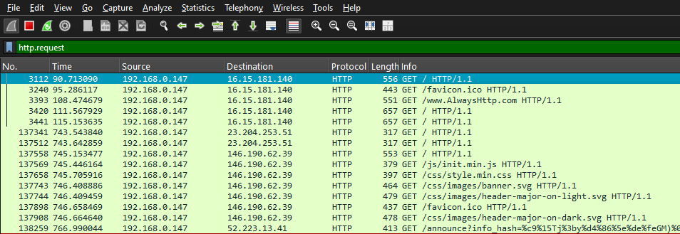
2.
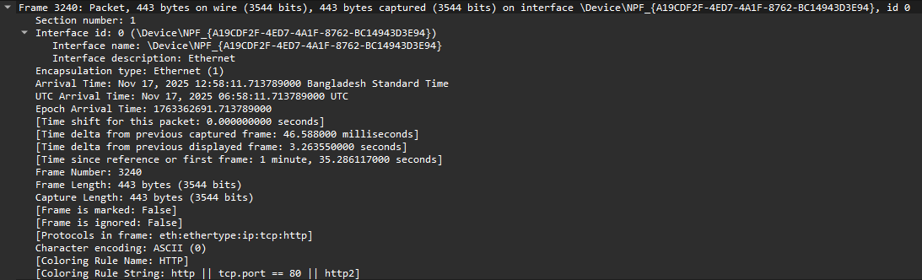
This layer falls under the Physical layer and is responsible for transmitting raw bit over the physical
medium, in this case the frame size is 443 bytes.
3.
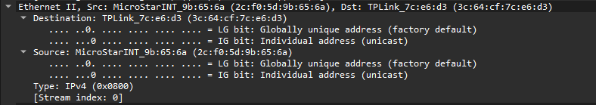
This is the Data link layer, this is adding MAC addresses to the local network delivery.
Source MAC Address: 2c:f0:5d:9b:65:6a
Destination MAC Address: 3c:64:cf:7c:e6:d3
4.
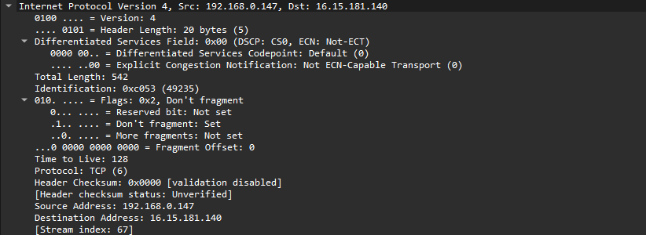
This layer is the Network layer that adds the source and destination IP which allows the packets to travel across the networks.
Source IP Address: 192.168.0.147
Destination IP Address: 16.15.181.140
5.
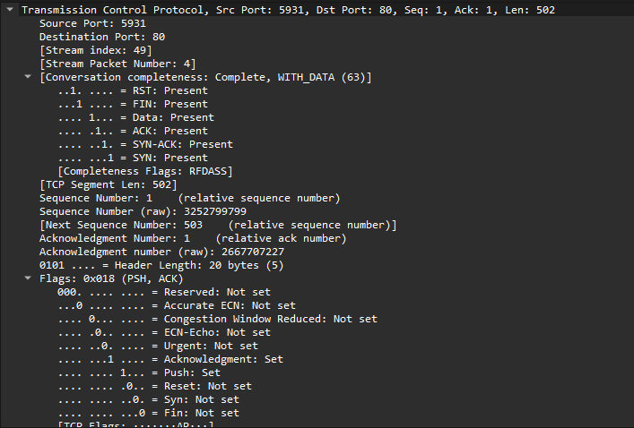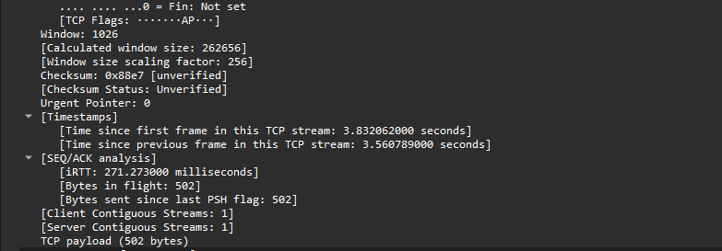This transport layer handles the port and sequence number establishment. Source Port: 5931, this port tells us from which port the source machine sent the TCP segment from. Destination Port: 80, A server port, on the receiving end, tells us where that TCP segment is going on the receiving end.
6.
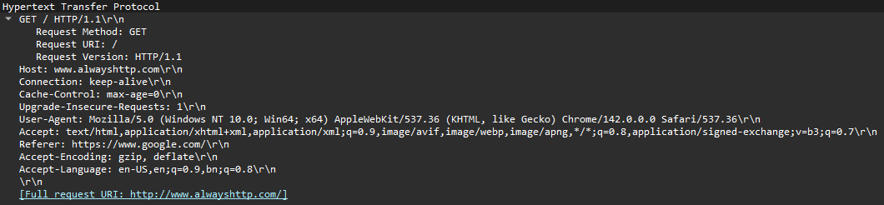
This application layer is running HTTP, and the request line tells us the version which is 1.1. The type is text. The connection type is keep-alive, which means http persistent connection, so for each transaction, the connection does not close and reopen separately.
HTTP Response:
1.
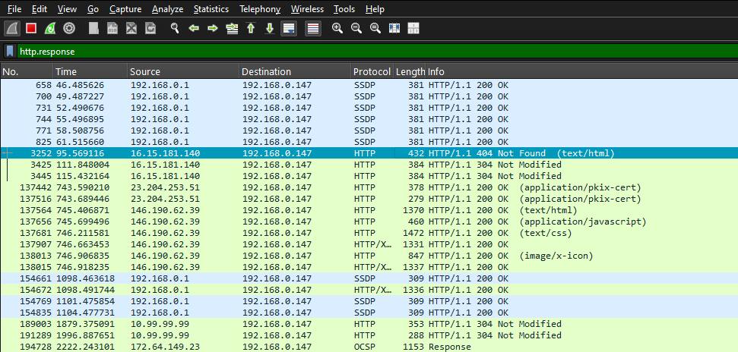
2.
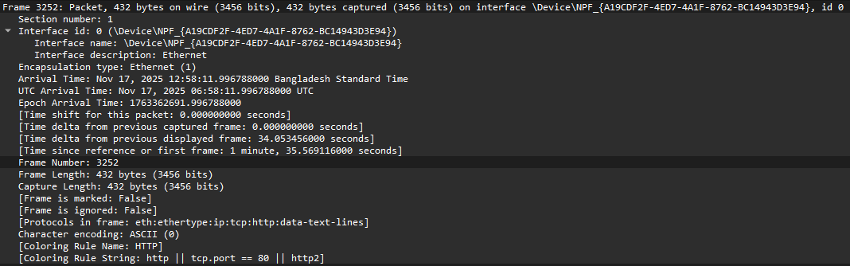
Falls under the Physical layer, transmits the frames physically via the medium.
Frame Length: 432 bytes.
3.
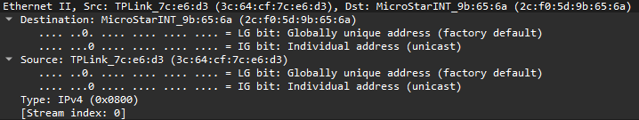
The Data Link layer adds MAC addresses for local network delivery.
Source MAC Address: 3c:64:cf:7c:e6:d3
Destination MAC Address: 2c:f0:5d:9b:65:6a
4.
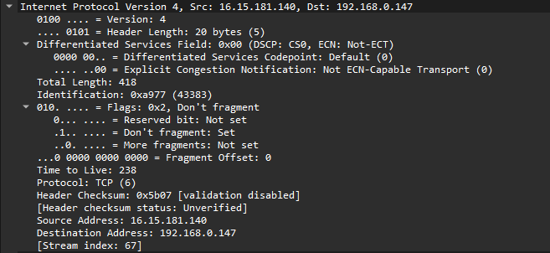
The Network layer gives the source and destination IP addresses to route the
packets across the networks.
Source IP Address: 16.15.181.140
Destination IP Address: 192.168.0.147
5.
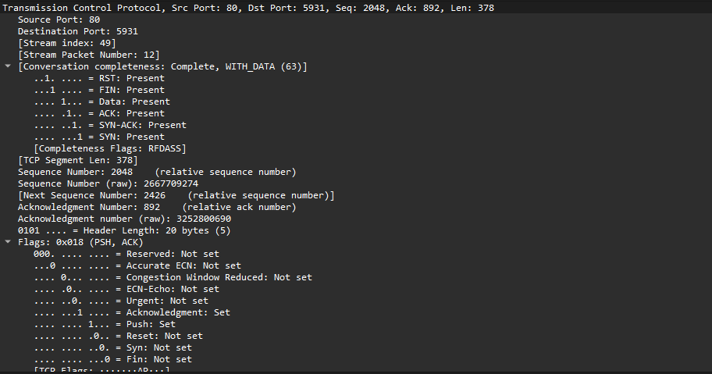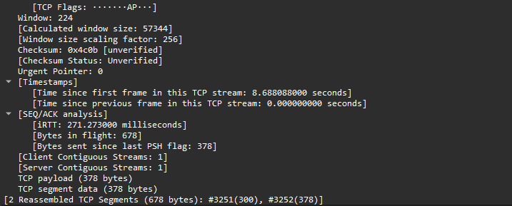
This layer handles the sequence number and port addressing.
Source Port: 80
Destination Port: 5931
Sequence Number: 2048, first byte of this segment
Acknowledgment Number: 892, confirms it received the previous 553 bytes from the
client
Segment Length: 378 bytes, data length.
6.
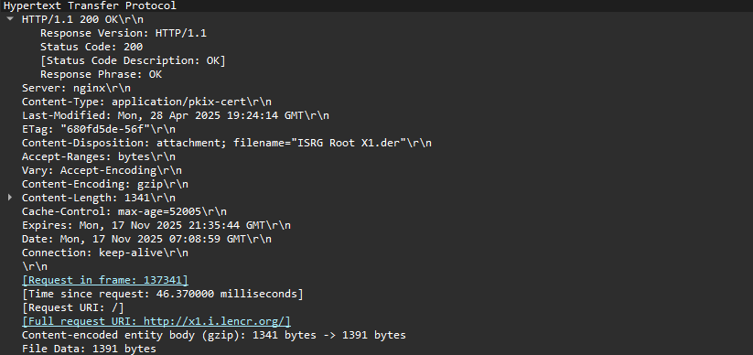
This application layer is running HTTP, and the request line tells us the version which is 1.1 The content length is 1391 bytes. This looks different than before because it is the response body of the previous request. The status code 200 OK means the request was successful.

